Department of Computer Science and Engineering
2025-2026
Odd Semester


DATA STRUCTURES AND ALGORITHMS-3
(25CS2103E)

NETWORK FLOW OPTIMIZATION

N. SIRI CHANDHANA 2520030142
A. SAI PRANATHI 2520030442
K. HEMALATHA 2520030147

COURSE INSTRUCTOR

Dr. J Sirisha Devi
Professor
Department of Computer Science and Engineering

NETWORK FLOW OPTIMIZATION
1.Introduction
Network Flow Optimization is an important problem in Data Structures and Algorithms that deals with finding the best possible flow of resources through a network. A network can be represented as a graph consisting of vertices (nodes) and edges (connections). Each edge has a certain capacity that represents the maximum amount of flow that can pass through it.
The main objective of network flow optimization is to determine how much flow can be transferred from a source node to a destination or sink node while satisfying the capacity restrictions of the network. The concept is useful in many real-world applications such as transportation systems, communication networks, water supply systems, computer networks, and supply chain management.
2. Problem Description
The main objective is to find the maximum possible flow from a source to a sink without exceeding the capacity of any edge.
The flow entering an intermediate node should also be equal to the flow leaving that node.
3. Representation of the Network
A network can be represented using a directed graph.
For example, consider a network with four nodes:
Source → A → B → Sink
Suppose the capacities are:
- Source → A = 10
- Source → B = 5
- A → B = 4
- A → Sink = 6
- B → Sink = 8
Here, the source is the starting node and the sink is the destination node. The numbers associated with the edges represent their maximum capacities.
The algorithm examines the available paths from the source to the sink and sends flow through these paths without exceeding the capacity of any edge.
4. Example of Network Flow
Consider the following simple network:
S → A → T
where:
- S = Source
- A = Intermediate node
- T = Sink
Assume:
Capacity(S,A) = 10
and
Capacity(A,T) = 6
Although the first edge can carry 10 units, the second edge can carry only 6 units. Therefore, the maximum possible flow from S to T is 6 units.
This example shows that the maximum flow is limited by the capacity of the bottleneck edge.
Now consider a slightly larger network:
S → A → T
S → B → T
Suppose:
- S → A = 10
- A → T = 6
- S → B = 5
- B → T = 5
The flow can be distributed through both paths.
Through the first path, a maximum of 6 units can be sent.
Through the second path, a maximum of 5 units can be sent.
Therefore, the total flow can be:
6 + 5 = 11 units
This demonstrates how multiple paths can be used to increase the total flow through a network.
5.Importance of Network Flow Optimization
- Helps find the maximum flow from a source to a destination.
- Helps manage limited network capacity efficiently.
- Identifies bottlenecks in the network.
- Helps distribute resources through multiple paths.
- Useful in computer networks for data transmission.
- Useful in transportation systems for traffic and goods movement.
- Useful in water supply systems for pipeline management.
- Useful in supply chain management for product distribution.
- Helps improve the efficiency of network systems.
6. Network Flow Optimization Using Graphs
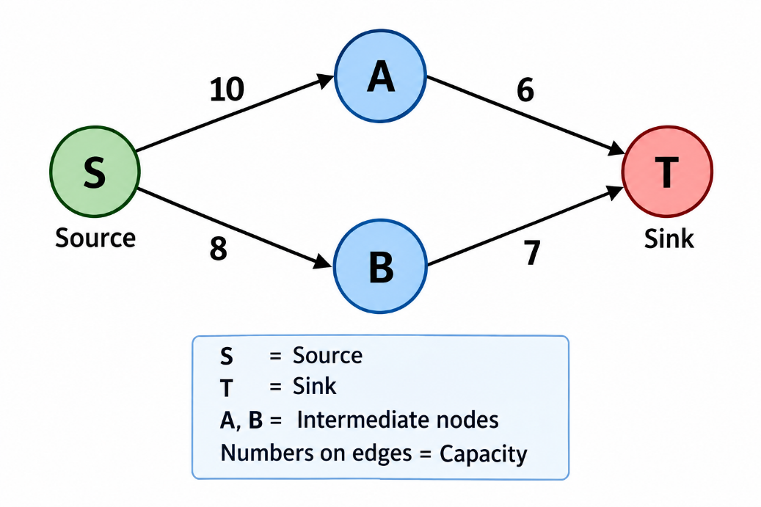
7. Maximum Flow
- Maximum flow finds the largest flow from source to sink.
- The smallest capacity on a path is the bottleneck.
- Example: 10 → 7 → 5, so maximum flow is 5 units.
- The process continues until no more flow can be sent.
8. Residual Network
- A residual network shows the remaining capacity after sending flow.
- Example: Capacity = 10, Flow = 4.
- Remaining capacity = 10 − 4 = 6 units.
- The updated capacity is used for further flow calculation.

9. Proposed Case Study
The proposed case study focuses on implementing a network flow optimization solution using graph-based data structures and algorithms.
The network is represented using nodes and directed edges. Each edge is assigned a capacity. The system takes the network information and identifies possible paths between the source and sink.
The algorithm then calculates the amount of flow that can be sent through each available path. After every flow operation, the remaining capacity of the edges is updated. The process continues until there is no possible path with available capacity from the source to the sink.
The final output represents the maximum flow that can be achieved for the given network.
12. Advantages
Network Flow Optimization provides several advantages:
- It efficiently manages the flow of resources through a network.
- It considers the capacity limitations of individual connections.
- It can identify bottlenecks in a network.
- It can utilize multiple paths between source and destination.
- It can be applied to many real-world problems.
- Graph data structures provide an effective representation of network connections.
- The algorithm can be implemented programmatically for different network configurations.

13. Conclusion
Network Flow Optimization is an important application of graph-based algorithms in Data Structures and Algorithms. It provides a systematic method for determining the maximum amount of flow that can move through a network from a source to a sink while respecting the capacity of every connection.
The concept can be applied to computer networks, transportation systems, water distribution, communication systems, and supply chain management. By representing the system as a graph and using appropriate flow algorithms, the available network capacity can be utilized effectively.
The proposed case study demonstrates how network flow concepts can be used to analyze a network, identify available paths, handle capacity restrictions, update remaining capacities, and determine the maximum possible flow between the source and destination.

ALGORITHM / PSEUDO CODE

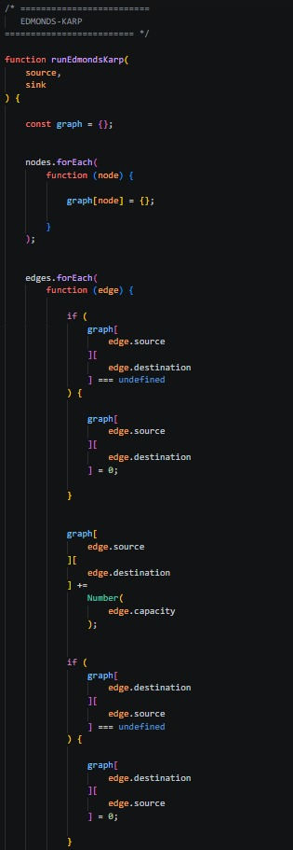
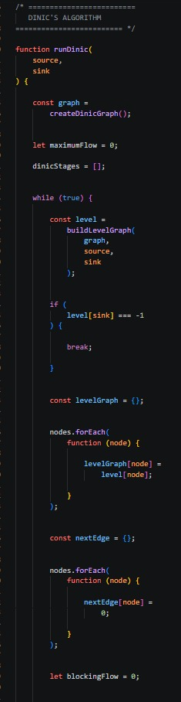
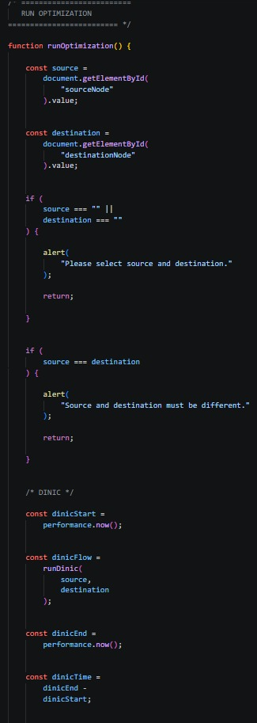
RESULTS
